**Valencia College — Employee Recognition**

**Shelby England**

**What will the app do?**

The employee recognition app will allow employees to share sentiments, kudos and comments that celebrates their colleagues. While the application will mainly be used to recognize departments on intervals, whether that be monthly or bi-weekly, employees will have not only the ability to add comments for any colleague in the system, but also be able to see what recognition their colleagues are receiving.

**What technologies will be implemented?**

* Animate on-scroll
  + Using for aesthetics
* CVS Uploader
  + Help ease of maintaining
* Image library and uploader
  + For employee profiles and gives the ability for employees to share memes
* Passport
  + Used to encrypt usernames and passwords

**Data Flow**

* User Sign in – data collected via forms and stored in a USER collection
  + Username
  + Password
  + Email address
* Employee Data – collected via csv uploader and stored in EMPLOYEE collection
  + Employee name
  + Employee department
  + Employee position
  + Employee start date (if I have time)
* Comments – collected via forms and stored in COMMENT collection
  + Comment Submitter
  + Comment Type
    - Image
    - Text
  + Comment Receiver
  + Comment Date

**Pages**

* Public page
* Login and Register
* Welcome
* Tagboard
* Employee Search
* Update page (accessed by employees to update their information, like name – if they get married)
* Admin page (that only accessible by admins)

**Previews**

**Public Page (no authentication required)**

­­­­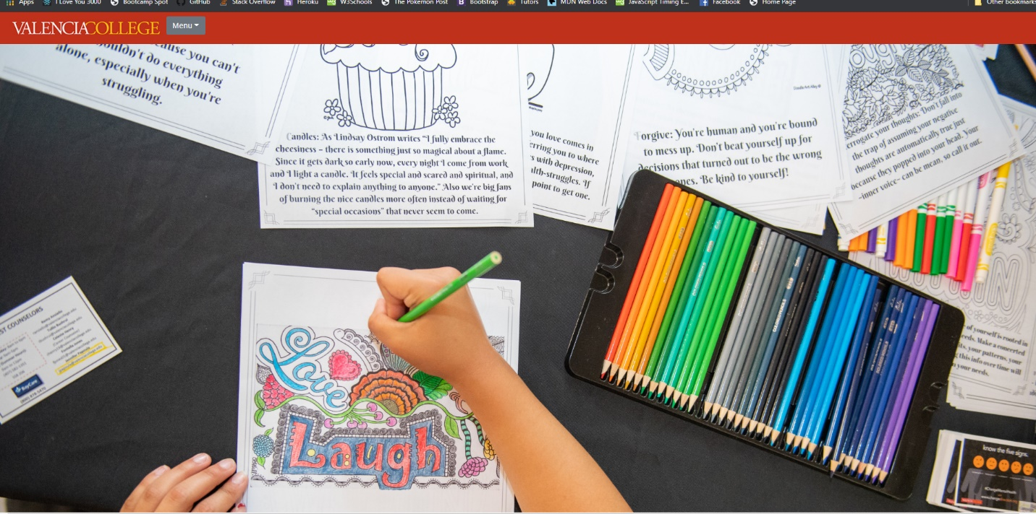

**Welcome Page (authetication required)**

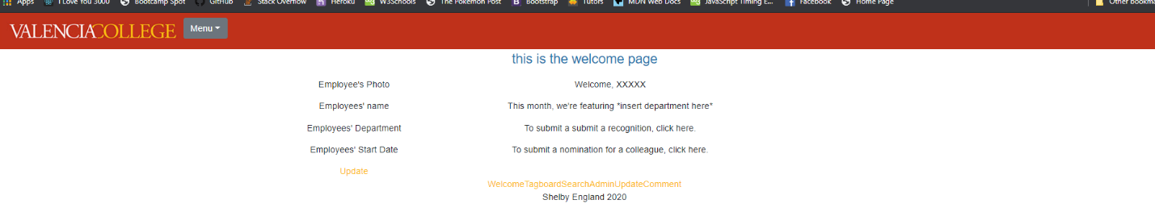

**Tagboard Page (authentication required)**



**Employee Search Page (authentication required)**

